Tableau Assignment 1

1. What exactly is Tableau?
2. Tableau is a tool which helps to fetching data from data source
3. Sort the files rightly on Dimensions, Measures, Set, Parameter, Groups & filers
4. Pills helps us to create the graphs
5. Tableau helps data join, union different data set
6. Creates Maps, Graphs & Interactive charts
7. Used to analysis the report
8. Create Interactive Sheets, Dashboard & stories
9. Finally, Tableau helps to publish the results in server\online clouds
10. What are the different Tableau products available?
    1. Tableau Public
    2. Tableau Desktop
    3. Tableau Server
    4. Tableau Online
    5. Tableau Prep builder
11. In Tableau, how many tables can you join at once?
    1. 32 tables can be joined together
12. What are the various types of connections you may establish with Tableau and your dataset?
    1. Live - Live document & will have dynamic changes based on others amend
    2. Extract – we need to download offline doc & need to do the changes
13. Analyze and respond to the following questions using the information provided. (6 to 8)
14. What is the store's overall revenue?

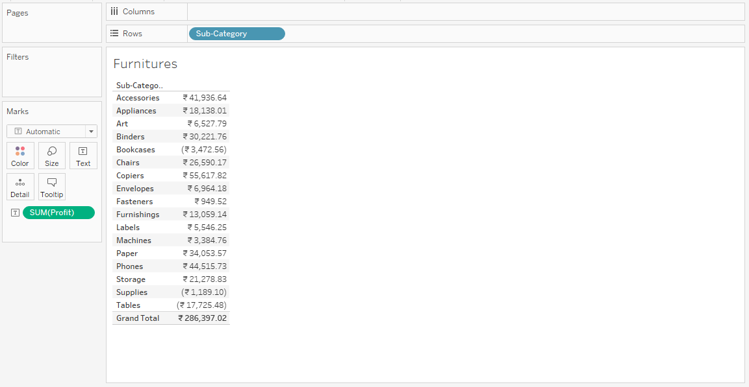

1. What is the total amount of furniture sold to the Customer Segment "Corporate"?

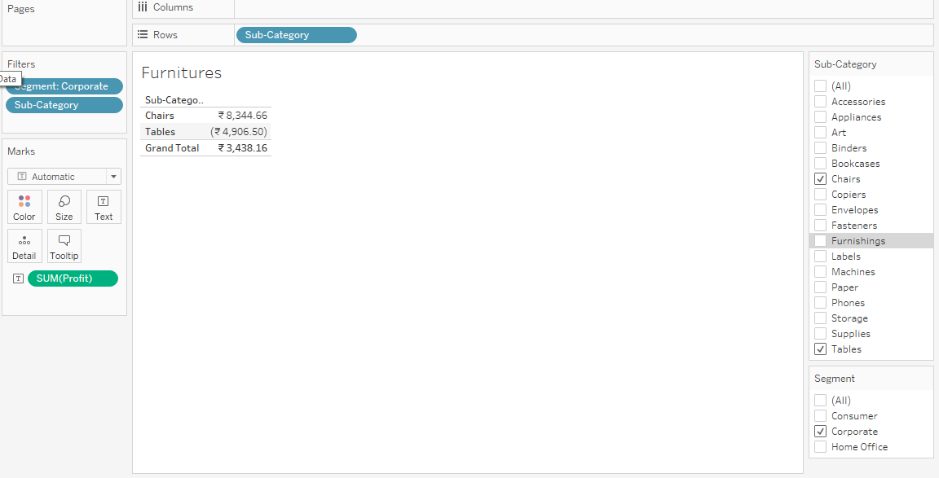

1. Calculate the average discount for each order priority and choose the one with the most significant value.

